1. 
2. Concurrency is nothing but multi-threading.
3. Multi-threading means to perform multiple activities at the same time.
4. **Real Life Example**:
   1. **I**n smart phones, apps are updating in the background.

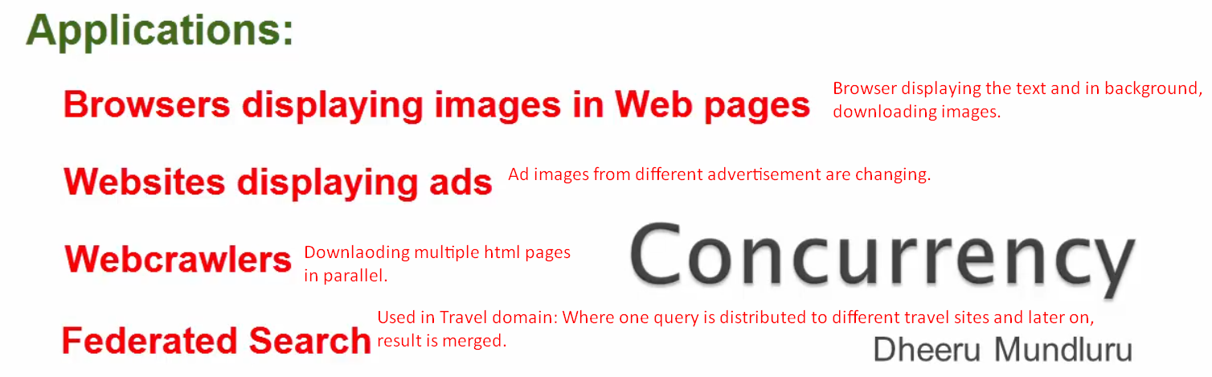

1. 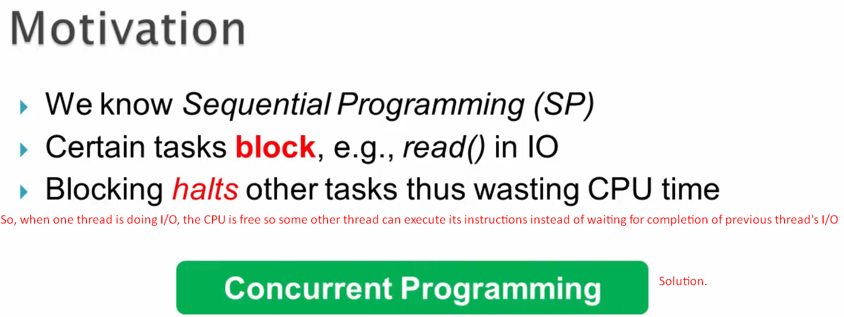
   1. JATIN: It doesn’t mean that when one thread does I/O, only then other thread would be given CPU. No matter, If it is I/O or not, we want to switch the CPU among threads to give a visualization that all tasks are executing in parallel so that none of them has to wait.
2. 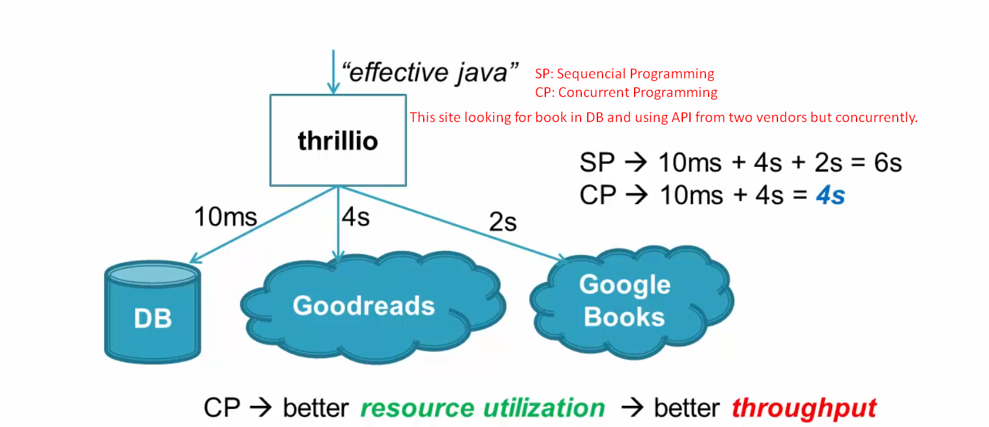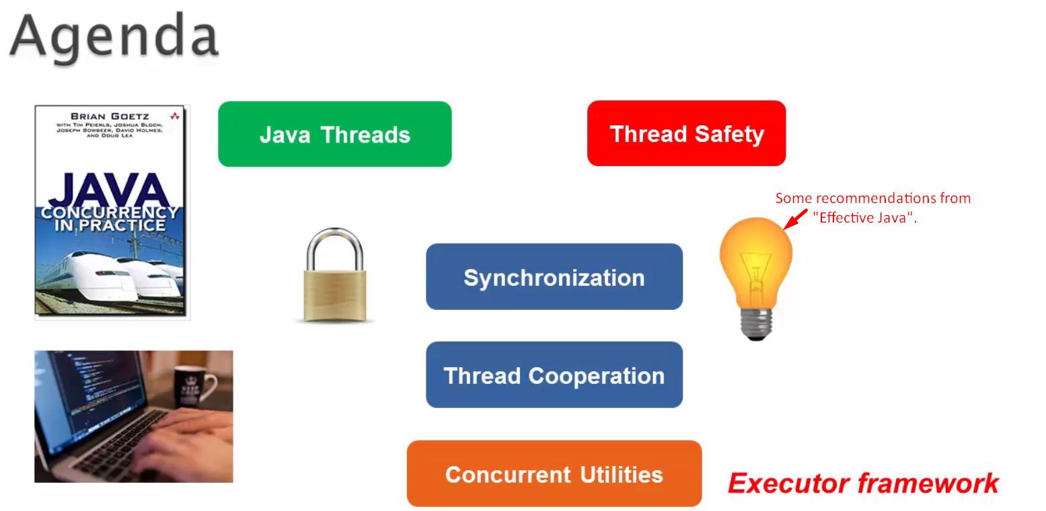
3. **Example**: Reading news paper and coffee is brewing.